Machine Description | A deliberately vulnerable lab machine for practicing web app exploits, privilege escalation, and post-exploitation to gain user and root access.
Target IP | 192.168.0.137
Vulnerability Name | - Information disclosure via an exposed SMB (Samba) share.  - Authenticated arbitrary file upload → Remote Code Execution (RCE) in the Koken CMS  - Misconfigured SUID binary → Local privilege escalation
Port / Service | TCP 8000 / http
Severity | 7.4 HIgh
Attack Vetor | CVSS:3.0/AV:L/AC:H/PR:N/UI:N/S:U/C:H/I:H/A:H
Proof of Concept (PoC) | STEP 1 – Nmap to find the IP of the target machine.  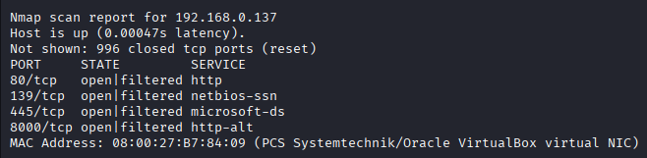  STEP 2 – Nmap Scan to discover open ports and Services  # nmap –p- –sV 192.168.0.137 –open  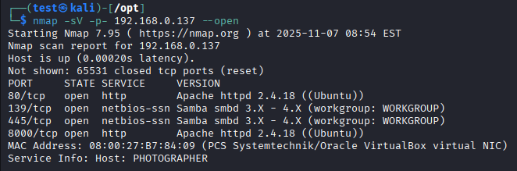  Step 3- We found a Sambashare using enum4linux on port 8000.  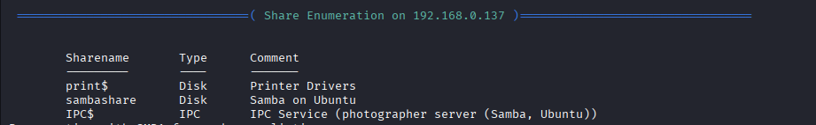  Step 4- Trying to login as null user and found  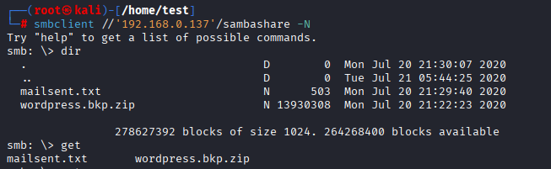  Step 5- We downloaded the mailsent.txt and found an email and potential password(babygirl).  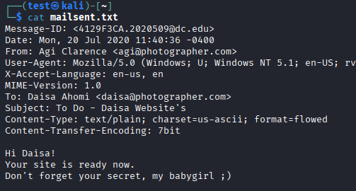  Step 6- By using Wfuzz we found an admin page on port 8000.  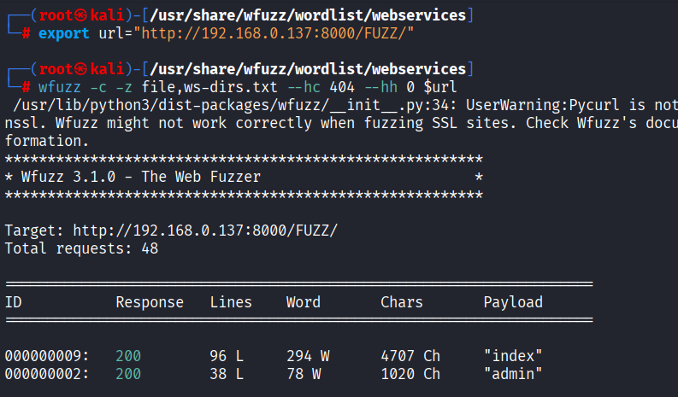  Step 7- We found an admin page on port 8000.  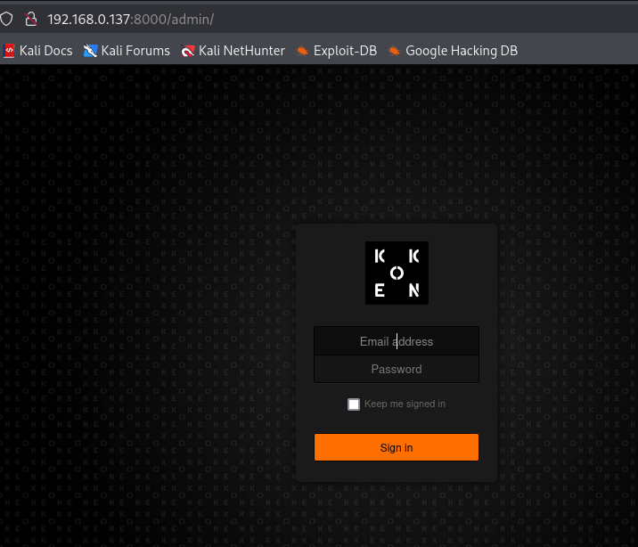  Step 8- we entered the details found in step 5  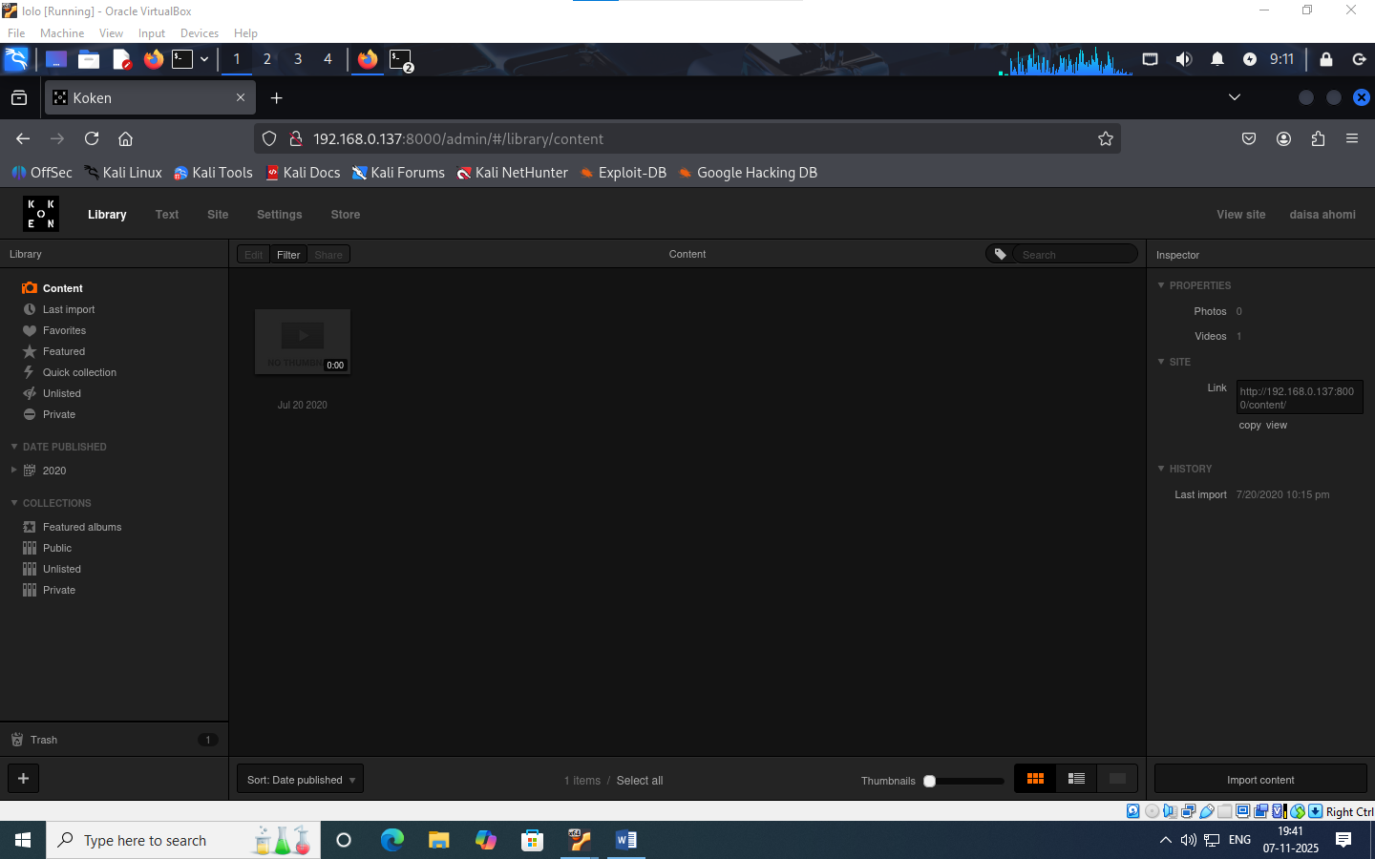  Step 9- First we need to create a reverse shell file with .jpg extension.  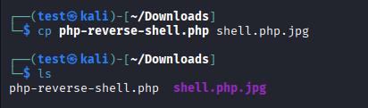  Step 10- We can upload Payloads using this admin page, but it only allows image format so we will use burp suite to intercept the transfer and change the file extension.  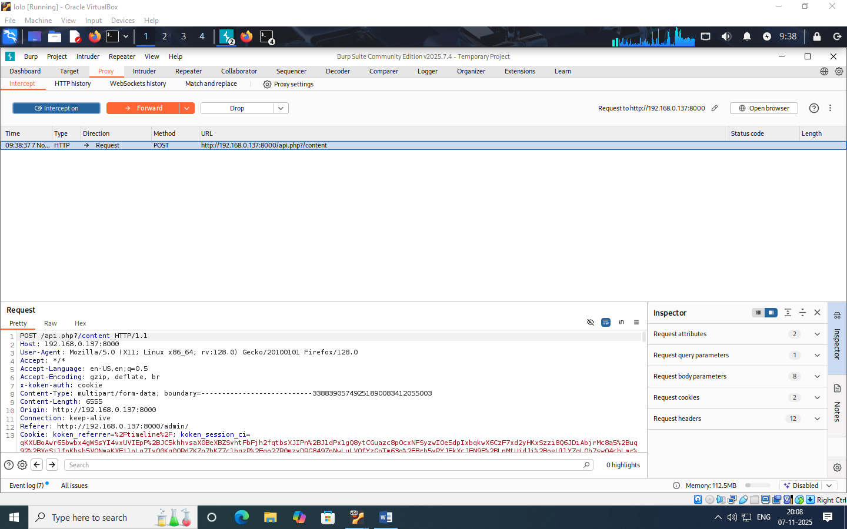  Step 11- Now we have to remove the .jpg that we added from 2 places like this:  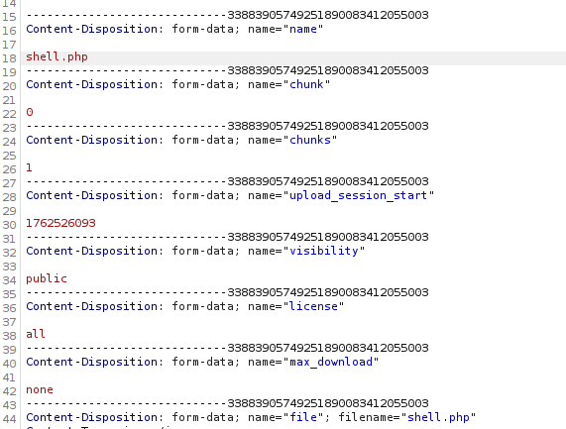  Step 12-Now forward the packet that go the koken page  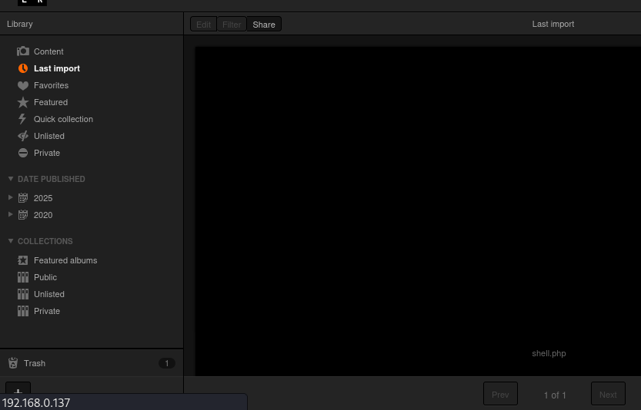  Step 13- Before we open the file to run the code, start a netcat listener  Step 14- After that go and try to download the file from koken server.  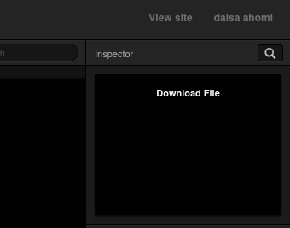  Step 15-You will have a shell on the netcat listener.  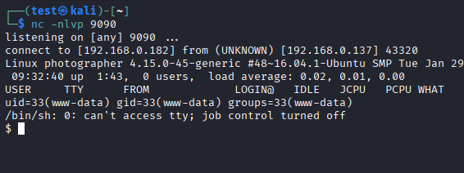  Step 16-After further enumeration we found a file with set user id permissions i.e php7.2.  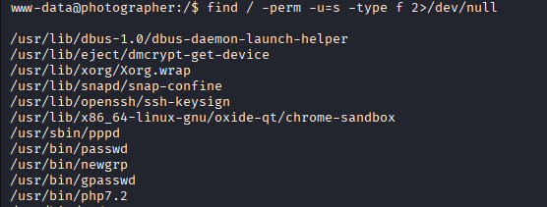  Step 17- we run the following commands for root  Proof:  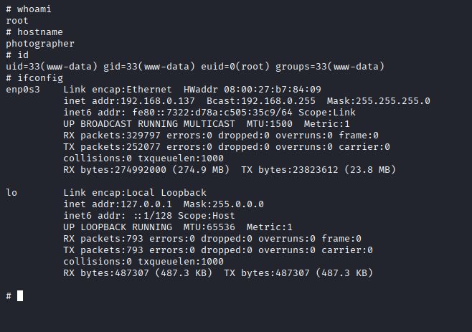  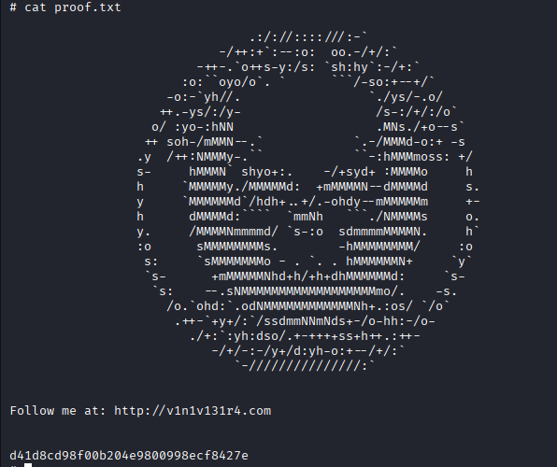
Remediation | • Remove secrets from SMB shares; restrict and password-protect access; rotate exposed credentials.  • Patch or replace Koken; disable/lock down uploads; allow only safe file types and store uploads outside web root.  • Audit and remove unnecessary SUID bits; update system packages; rebuild from clean backup if compromise suspected.
Impact | . • Credentials exposed via SMB — attackers can find admin passwords and log in.  • Authenticated file-upload → RCE (Koken CMS) — attacker with creds can upload a web-shell and run commands.  • SUID misconfiguration → Privilege escalation — local user can abuse a privileged binary to gain root.
References | - https://portswigger.net/web-security/file-upload?utm_source=chatgpt.com  - https://www.elastic.co/guide/en/security/8.19/privilege-escalation-via-suid-sgid.html?utm_source=chatgpt.com  - https://www.vulnhub.com/entry/photographer-1%2C519/?utm_source=chatgpt.com

